# **PREFACE**

First of all, thanks to Allah SWT because we can completed this ISAS task both in the form of presentation. We want to deliver sincere especially for Mr. Hudya faculty and another faculty who always help. Thank you also to fellow students who have supported, and also thank you for being fellow workers in the education at CCIT-FTUI.

The ISAS paper entitled ‘Virtual Memory in Windows 10 Operating System' the writers submits as ISAS's 2019 task requirements.

Hope of the writers, hopefully this paper can be useful for all so that it can add knowledge and insight. The writers realize that this paper is far from perfect. Therefore, the writers expect all suggestions and criticisms from readers who are constructive for the perfection of this paper.

Finally, hopefully this paper can provide many benefits for the readers.

Depok, November 2019

Writers

**TABLE OF CONTENT**

**TABLE OF FIGURE**

**CHAPTER III**

Figure 3.1 Manual Step 1

Figure 3.2 Manual Step 2

Figure 3.3 Manual Step 3

Figure 3.4 Manual Step 4

Figure 3.5 Manual Step 5

Figure 3.6 Manual Step 5.1

Figure 3.7 Manual Step 6

Figure 3.8 Manual Step 7

Figure 3.9 Change Location 1

Figure 3.10 Change Location 2

Figure 3.11 Change Location 3

Figure 3.12 Change Location 4

Figure 3.13 Change Location 5

Figure 3.14 Change Location 6

# **CHAPTER I**

# **INTRODUCTIONS**

1. **Background**

The existence of technology is very helpful to human life in carrying out their various jobs. Technology makes people feel like there is no difficulty in carrying out their daily activities. Computers are one of the technologies that really help humans in doing many works, a computer is a tool that use to process data based on predetermined standard rules [1].

If described according to experts, the computer can be interpreted as a tool that can perform many tasks that accept input, process input, store, and make output. At this time the development of computers has entered the fifth generation, new standards in the PC industry will be more widely applied and more developed by companies such as Windows and Intel [1].

To run a computer, we need an operating system that can accommodate the function of many hardware such as memory, CPU, hard disk, and other hardware. And then, you can also set program or software functions to connect with the hardware.

The most widely used operating system is Windows, the latest Windows edition released by Microsoft is Windows 10. The existence of virtual memory is very helpful and alleviates the function of RAM while working. Although virtual memory has a significant role in computer systems, there are still many users who think that virtual memory is not that useful.

On Windows 10, virtual memory (paging file) is an essential component ( hidden file ) is designed to remove and temporarily store less frequently use modified pages allocated in RAM ( random-access memory ) to the hard drive. Using this approach allows the system to prioritize faster physical memory for more frequent processes and applications, improving the device from locking up in the event it runs out of system memory [2].

In Windows 10, application and many system processes always reference memory by using virtual memory address. Virtual memory is always being used, even the memory that is required by all running processes does not exceed the volume of RAM that is installed on the system. Many operating system have their own method to save page table. Some operating system allocate a page table for each processes [3].

In the operating system based on Windows NT there is a component that manage the virtual memory, named Virtual Memory Management (VMM) that have many function such as placing a virtual address that owned by a process that run into the physique memory page in the computer.

1. **Purpose of Writing**

The purpose of writing a paper about the Virtual Memory in Windows 10 is :

1. To work on tasks related to the Operating System
2. To learn more about Virtual Memory in Windows 10
3. **Problem Domain**

As for the problem of writing this ISAS are:

1. Describe Definition of Operating System
2. Describe Definition of Windows 10
3. Describe Definition of Memory
4. Describe Definition of Virtual memory
5. Describe Steps to manually set page file in Windows 10
6. Describe Steps to change the location a page file
7. Describe Function of Virtual Memory
8. **Learning Methodology**
9. Method Library

The method used in writing this ISAS paper is by searching for information from reference sources contained on the online sites related to the information contained in this ISAS discussion.

1. Discussion

Obtain complete data by collecting it through various sources of information available on the internet to make ISAS papers.

1. **Writing Framework**

**Chapter I Introduction**

1. Background
2. Purpose of Writing
3. Problem Domain
4. Learning Methodology
5. Writing Framework

**Chapter II Basic Theory**

1. Definition of Operating System
2. Definition of Windows 10
3. Definition of Memory
4. Definition of Virtual Memory

**Chapter III Problem Analysis**

1. Describes Steps to manually set page file in Windows 10
2. Describes Function of Virtual Memory

**Chapter IV Conclusion and Suggestion**

1. Conclusion
2. Suggestion

**CHAPTER II**

**BASIC THEORY**

1. **Definition of Operating System**

Operating System (OS) is software with the task of controlling and managing hardware as well as basic system operations, including running application software such as data processing programs that can be used to facilitate human activities [4].

For hardware functions such as input, output, and memory allocation, the operating system acts as an intermediary between programs and computer hardware. The operating system we can use such as on Smartphones, Tablets, Laptops, Desktop Computers [5].

The computer operating system is the first layer of software that is placed on the computer's memory (hard disk) when the computer is turned on. Whereas other software is run after the Computer Operating System runs, and the Operating System will perform general core services for the software. These common core services are disk access, memory management, task scheduling, and user interfaces. So that each software no longer needs to perform common core tasks, because it can be served and performed by Operating System.

1. **Definition of Windows 10**

Windows 10 is a series of personal computer operating systems produced by Microsoft as part of its Windows NT family of operating systems. It is the successor to Windows 8.1, and was released to manufacturing on July 15, 2015, and broadly released for retail sale on July 29, 2015. Windows 10 is an OS that can be used on a variety of devices, from PCs to the Internet of Things (IoT). Microsoft said that they have tested this latest OS on more than 2,000 different devices [6].

1. **Definition of Memory**

Memory (or more accurately called physical memory) is a generic term that refers to temporary data storage media on a computer. Every program and data that is being processed by the processor will be stored in physical memory. Data stored in physical memory is temporary because the data stored in it will be stored as long as the computer is still powered (in other words, the computer is still alive).

Memory can be either volatile and non-volatile memory. Volatile memory is memory that loses its contents when the computer or hardware device loses power. Computer RAM is an example of volatile memory [7].

It is why if your computer freezes or reboots when working on a program, you lose anything that hasn't been saved. Non-volatile memory, sometimes abbreviated as NVRAM, is memory that keeps its contents even if the power is lost. EPROM is an example of non-volatile memory [7].

1. **Definition of Virtual Memory**

Computers have two types of memory. First of all, hard drive or solid-state drive, which is used for operating systems and storing data such as photos, files, music, documents and so on. The second is RAM, used to store data temporarily from applications, software or processes. The hard disk is very suitable for storing files in the long run, while RAM works faster and more stable, its job is to maintain the computer's performance of the programs and files that you are opening [8].

Virtual memory is very useful. If you use all the space from RAM to run the processes in your Personal Computer, virtual memory will handle other processes. Virtual memory can be created using memory on the hard disk. In the Windows NT-based operating system, there is a component that given virtual memory named Virtual Memory Manager (VMM) which has the function of being able to map virtual addresses associated with a process that runs into a physical memory page on the computer [8].

# **CHAPTER III**

# **PROBLEM ANALYSIS**

Page file in Windows 10 is a hidden system file with a .SYS extension. Usually this pagefile.sys file is stored on the C: \ directory of the computer system drive. This page file is useful to reduce the workload of physical memory (RAM) that have been installed so that the computer can work smoothly.

1. **Steps to manually set page file on Windows 10**
2. Open the Run application by typing "Run" in the search box in the left corner of the Taskbar [9]

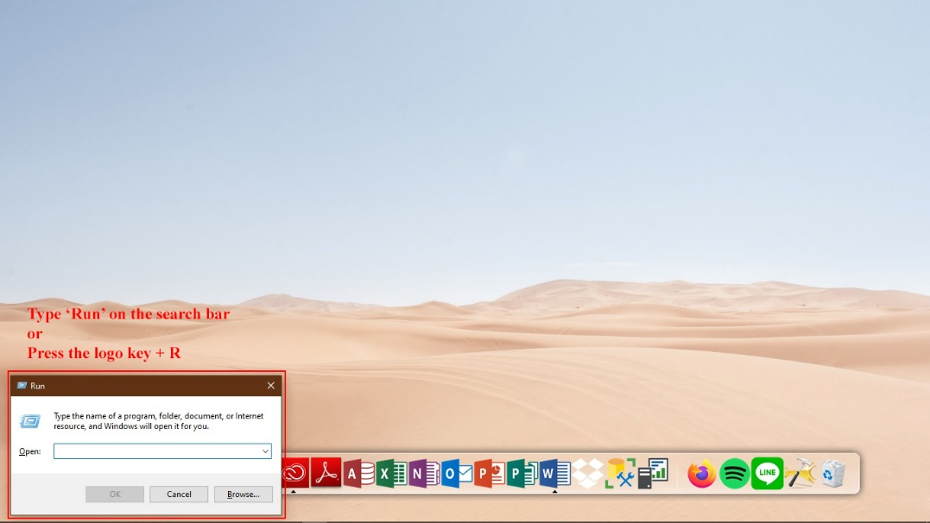

**Figure 3.1 Manual Step 1**

1. Type: SystemPropertiesAdvanced [9]

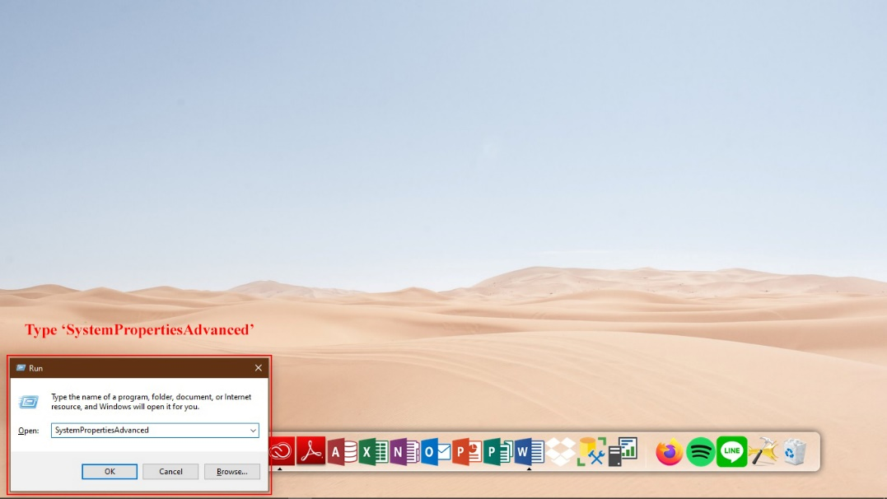

**Figure 3.2 Manual Step 2**

1. The System Properties window will appear, in the Performance section click Settings [9]

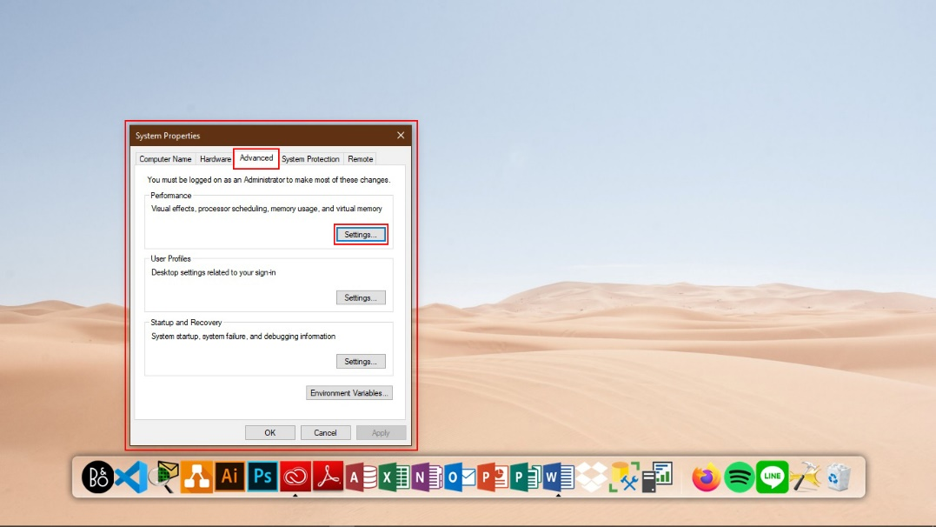

**Figure 3.3 Manual Step 3**

1. The System Performance Options window will appear, click Change in the Virtual memory selection in the Advance tab [9].

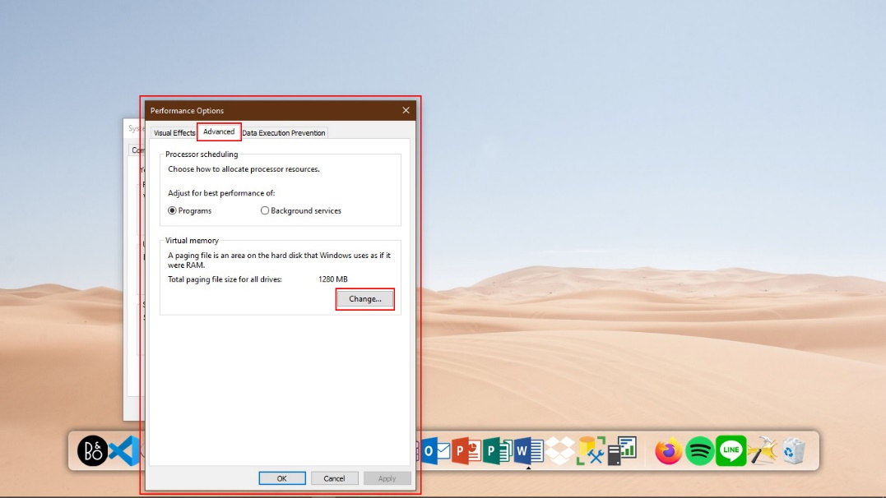

**Figure 3.4 Manual Step 4**

1. Uncheck the Automatically manage paging file size for all drives option and fill in the Initial and Maximum Size section [9].

A screenshot of a computer

Description generated with very high confidence

**Figure 3.5 Manual Step 5**

A screenshot of a computer

Description generated with very high confidence

**Figure 3.6 Manual Step 5.1**

The size of the virtual memory is unique to each device, and it can’t be generalized. However, usually, it’s recommended to use a number that’s one and a half times the total available memory for the “Initial size” and three times of available memory for the “Maximum size” when possible.

1. Click Set button and OK [9]

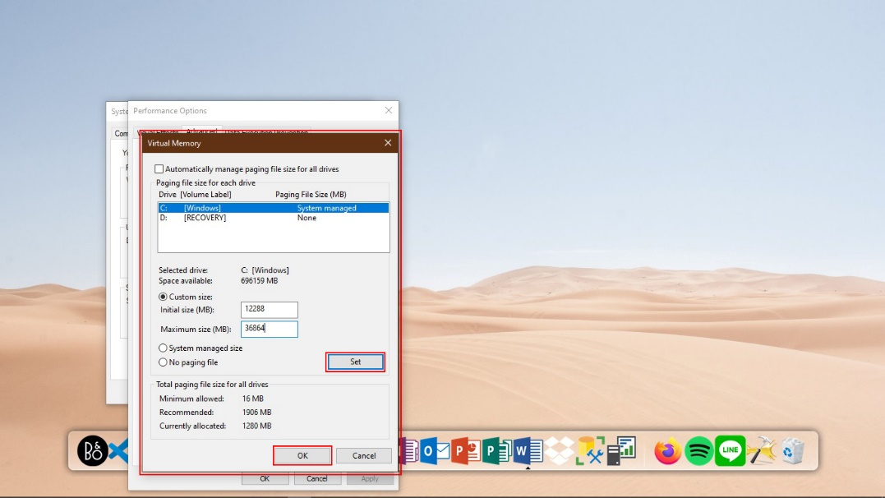

**Figure 3.7 Manual Step 6**

1. Click OK and restart the computer [9].

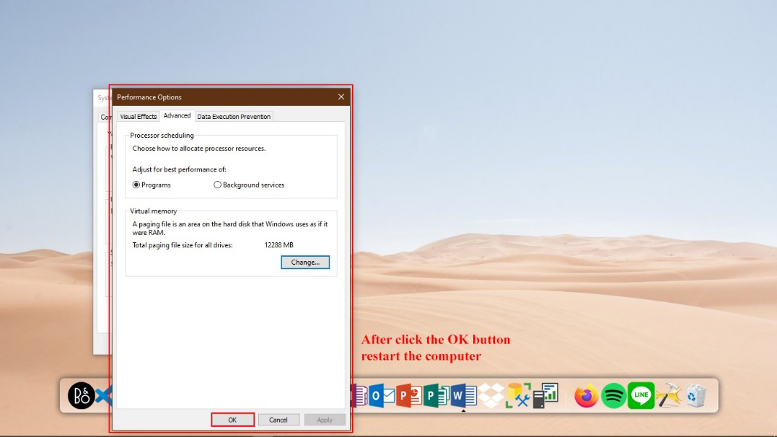

**Figure 3.8 Manual Step 7**

1. **Change the location a page file**
2. Open the Run application by typing "Run" in the search box in the left corner of the Taskbar [9]



**Figure 3.9 Change Location 1**

1. Type : SystemPropertiesAdvanced [9]



**Figure 3.10 Change Location 2**

1. The System Properties window will appear, in the Performance section click Settings [9]



**Figure 3.11 Change Location 3**

1. The System Performance Options window will appear, click Change in the Virtual memory selection in the Advance tab [9].



**Figure 3.12 Change Location 4**

1. Uncheck the Automatically manage paging file size for all drives option. Choose the default location of page file and select the No paging file button and click the Set button. [9]

A screenshot of a computer

Description generated with very high confidence

**Figure 3.13 Change Location 5**

1. Select the new location for page file and select System managed size button and click the Set button and OK button. Close all tab and restart the computer [9]

A screenshot of a computer

Description generated with very high confidence

**Figure 3.14 Change Location 6**

1. **Function of Virtual Memory**
2. Handle the excess load of RAM

If a computer with 2GB of RAM needs to store many data more than its maximum capacity, let's say 2.3GB. The computer will certainly make an excess load of its RAM and as a result, the computer will hang, lag, or will not respond at all. Hopefully, the overheat won't damage the chip in RAM, therefore virtual memory plays an active role to handle the excess, virtual memory capacity is taken from the hard disk drive capacity [10].

1. Becomes a backup RAM, but does not replace the RAM function.

In general RAM functions is to store data that will be processed by the processor or data from running activities. If there are Virtual Memory, it does not mean the computer does not need the RAM and can run the activity in the absence of RAM installed on a computer [10].

1. Saves data from RAM, but not transferred to the processor

Virtual memory serves as a backup memory which only helps to overcome the lack of memory capacity. Unlike RAM, virtual memory does not forward data stored for processing by the processor. So, when data stored in virtual memory will be processed, virtual memory will forward it to RAM and RAM will forward it to the processor [10].

1. Data that stored in virtual memory (paging file) is temporary

Just like RAM, Virtual memory will be empty after the computer turned off. The paging file or data contained in the SWAP partition will also be deleted after the computer turned off, it is different from the concept of storing data on a hard disk drive even though the media is the same (virtual memory takes the hard disk drive capacity) [10].

# **CHAPTER IV**

# **CONCLUSION AND SUGGESTION**

1. **Conclusion**

From this ISAS, we can conclude that virtual memory still become one of the most important in computer system, although many user do not want to know or understand more about virtual memory

1. **Suggestion**

From this ISAS, we can suggest anyone who uses computer to know more and try to start thinking that virtual memory is one from many important things or part that need to exist in our computer system

**BIBLIOGRAPHY**

[1] [RomaDecade] [Sejarah Komputer] [12/10/2019] <https://www.romadecade.org/sejarah-komputer/#!> [15/11/2019]

(Pheenix, 2019)

[2] [Windows Central] [Running low of virtual memory? Use these steps to increase it on Windows 10] [14/11/2019] <https://www.windowscentral.com/how-change-virtual-memory-size-windows-10> [16/11/2019]

(GoDaddy.com, 2019)

[3] [support.microsoft.com] [{{search404Captions.content404Title}}] <https://support.microsoft.com/id-id/help/2160852/ram-virtual-memory-pagefile-and-memory-management-in-windows> [16/11/2019]

[4] [Techopedia] [What is an Operating System (OS)?] <https://www.techopedia.com/definition/3515/operating-system-os> [17/11/2019]

[5] [Cleverism] [What Is an Operating System (OS) and How Does It Work] [27/11/2016] <https://www.cleverism.com/operating-system-os-guide/> [17/11/2019]

[6] [SearchEnterpriseDesktop] [What is Microsoft Windows 10? Definition from WhatIs.com] <https://searchenterprisedesktop.techtarget.com/definition/Windows-10> [17/11/2019]

[7] [Computer Hope] [What is Memory?] [03/09/2019] <https://www.computerhope.com/jargon/m/memory.htm> [18/11/2019]

[8] [kangtokkomputer] [Pagefile Virtual Memory] <http://kangtokkomputer.weebly.com/pagefile-virtual-memory.html> [18/11/2019]

[9] [Microsoft Community] [How to Increase Virtual Memory in Windows 10: A Quick Guide] [03/04/2018] <https://answers.microsoft.com/en-us/windows/forum/windows_10-performance/how-to-increase-virtual-memory-in-windows-10-a/46dacaf5-15cf-4f5d-9d5a-cba1401ae4c9> [18/11/2019]

[10] [DosenIT.com] [4 Fungsi Virtual Memory pada Sistem Operasi] [17/12/2016] <https://dosenit.com/hardware/ram/fungsi-virtual-memory> [19/11/2019]

# Bibliography

Pheenix, I. (2019, October 12). *Sejarah Komputer*. Retrieved November 15, 2019, from RomaDecade: https://www.romadecade.org/sejarah-komputer/#!

Cleverism.com. (2019, September 23). *What Is an Operating System (OS) and How Does It Work*. Retrieved November 17, 2019, from Cleverism: https://www.cleverism.com/operating-system-os-guide/

Community, M. (n.d.). *How to Increase Virtual Memory in Windows 10: A Quick Guide*. Retrieved November 11, 2019, from Microsoft Community: https://answers.microsoft.com/en-us/windows/forum/windows_10-performance/how-to-increase-virtual-memory-in-windows-10-a/46dacaf5-15cf-4f5d-9d5a-cba1401ae4c9

DosenIT.com. (2016, November 17). *4 Fungsi Virtual Memory pada Sistem Operasi*. Retrieved November 19, 2019, from DosenIT.com: https://dosenit.com/hardware/ram/fungsi-virtual-memory

GoDaddy.com, L. (2019, November 14). *Running low of virtual memory? Use these steps to increase it on Windows 10*. Retrieved November 16, 2019, from Windows Central: https://www.windowscentral.com/how-change-virtual-memory-size-windows-10

Hope, C. (2019, September 3). *What is Memory?* Retrieved November 18, 2019, from Computer Hope: https://www.computerhope.com/jargon/m/memory.htm

kangtokkomputer. (n.d.). *Pagefile Virtual Memory*. Retrieved 11 18, 2019, from kangtokkomputer: http://kangtokkomputer.weebly.com/pagefile-virtual-memory.html

Pheenix, I. (2019, October 12). *Sejarah Komputer*. Retrieved November 15, 2019, from RomaDecade: https://www.romadecade.org/sejarah-komputer/#!

SearchEnterpriseDesktop. (n.d.). *What is Microsoft Windows 10? Definition from WhatIs.com*. Retrieved November 17, 2019, from SearchEnterpriseDesktop: https://searchenterprisedesktop.techtarget.com/definition/Windows-10

support.microsoft.com. (n.d.). *RAM, virtual memory, pagefile, and memory management in Windows*. Retrieved November 16, 2019, from Microsoft: https://support.microsoft.com/id-id/help/2160852/ram-virtual-memory-pagefile-and-memory-management-in-windows

Techopedia.com. (n.d.). *What is an Operating System (OS)? - Definition from Techopedia*. Retrieved November 17, 2019, from Techopedia: https://www.techopedia.com/definition/3515/operating-system-os